Fine Motor Skills at Home
Fine motor skills involve the muscles in our hands, fingers and thumb. They allow us to hold a pencil and write, dress ourselves, feed ourselves, use our tablets and many more things. It is important that young children develop these skills so they have dexterity and strength in their hands. Here is a small selection of activities that you can do at home to work on fine motor skills. Choose what works for you and your son. And most importantly have fun!
- Clothes pegs: practice putting the pegs on and off different items around the house. The clothes line (if you can reach), a piece of card, a paper plate, the rim of a plastic cup or even your own clothes.
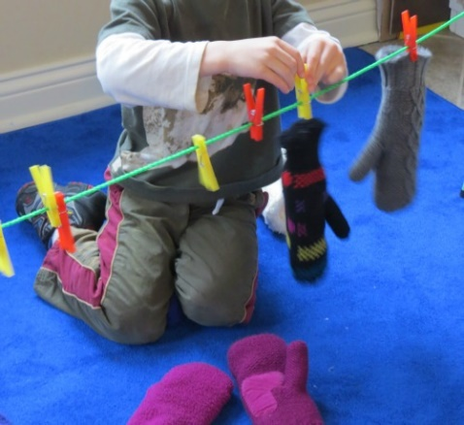
- Find a shirt and practice opening and closing the buttons.
- Cutting: with supervision, see what you have around the house that you can cut. Paper, card, playdough, even cooked spaghetti!
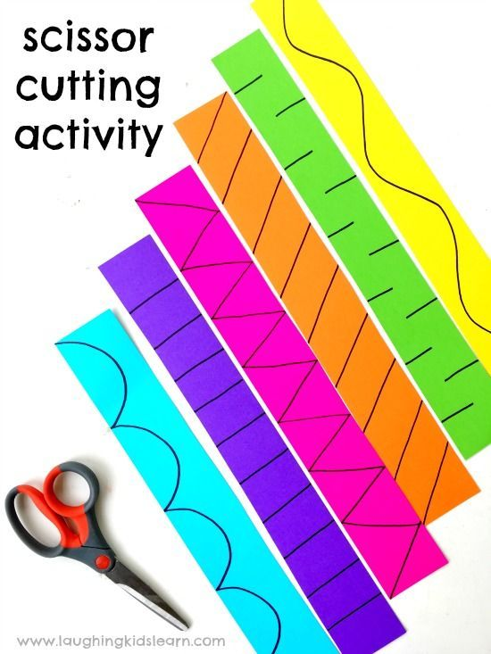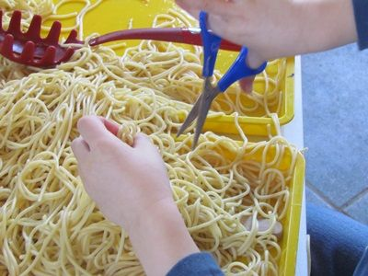
- Play dough: roll, squeeze, pull, tug, pinch, shape. Play dough is great for building strong muscles in your hands. Can you make numbers or the letters in the alphabet with playdough?
- Getting dressed: Getting dressed all by ourselves is a great thing to practice while we are not in school. Buttoning your trousers or shirt by yourself, putting on your own socks and shoes, zipping up your coat and putting on your own hat, scarf or gloves.
- Pasta: uncooked pasta can be used in lots of ways for fine motor skills. Spaghetti can be threaded through a colander or even through some penne pasta.
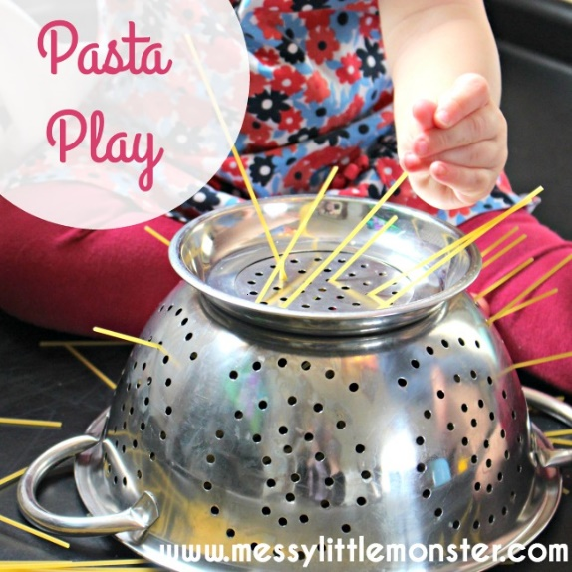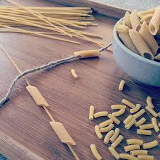
- Sorting: use whatever small items you might have around the house to sort: lego, buttons, blocks even food such as pasta or cereal. Use your finger and thumb to move the items from one container to another.
